Water Filter Test Results
All the filters were tested using the same laboratory protocol and ICP-MS instrumentation, all on the same day.
 |  | Percent REMOVAL of elements from tested water filters
 |  | Aluminum | Copper | Arsenic | Strontium | Cadmium | Cesium | Mercury | Lead | Uranium
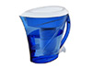 | ZeroWater | 100% | 99.1% | 99.3% | 100% | 99.2% | 100% | 99.4% | 99.2% | 99.1%
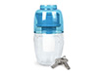 | WaterMan | 62.4% | 89.2% | 54.0% | -179.0% | 49.1% | 25.7% | 99.7% | 93.7% | 72.4%
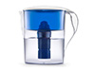 | Pur | -46.8% | 27.6% | 19.8% | 15.4% | 17.4% | 27.8% | 98.9% | 34.9% | 31.5%
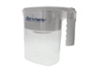 | Seychelle | -27.9% | 39.9% | 78.4% | 30.2% | 27.8% | 38.7% | 99.6% | 72.0% | 43.2%
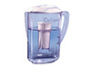 | Culligan | -52.4% | 30.8% | 16.0% | 27.8% | 22.6% | 30.4% | 62.4% | 30.2% | 28.6%
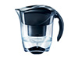 | Mavea | 8.1% | 18.8% | 18.6% | 2.4% | 9.2% | 15.3% | 85.0% | 23.4% | 22.7%
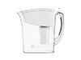 | Brita | -33.9% | 8.6% | 12.1% | 3.6% | 6.6% | 9.5% | 74.6% | 14.1% | 10.0%

Minus sign signifies an INCREASE in the element rather than a decrease!!

